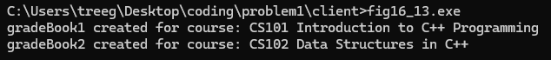

Problem1 result

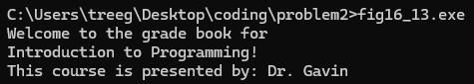

Problem 2 result

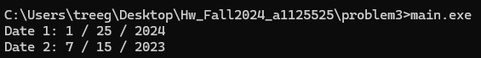

Problem3 result